Project Design Phase-II Technology Stack (Architecture & Stack)

|  |  |
| --- | --- |
| Date | 13 October 2022 |
| Team ID | PNT2022TMID25227 |
| Project Name | Early Detection of Chronic Kidney Disease  using Machine Learning |
| Maximum Marks | 4 Marks |

# Technical Architecture:

The Deliverable shall include the architectural diagram as below and the information as per the table1 & table 2

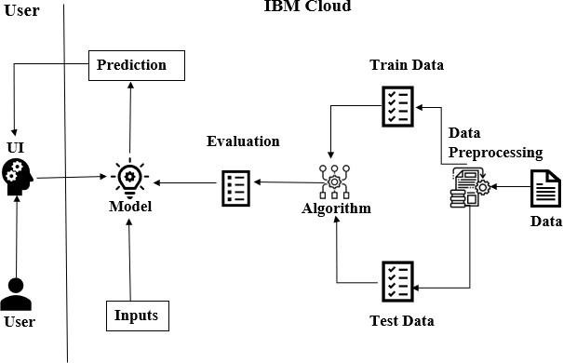

# Table-1 : Components & Technologies:

|  |  |  |  |
| --- | --- | --- | --- |
| **S.No** | **Component** | **Description** | **Technology** |
| 1. | User Interface | User interact with our application through web  User Interface. | HTML, CSS and Python flask. |
| 2. | Application Logic-1-Login. | When the user click on the login button , he/she is directed to login page, if they are registered already. | HTML ,CSS, Python flask. |
| 3. | Application Logic-Registration | When the user click on the Register button , he/she is directed to Register page for further process. | HTML,CSS, Python flask. |
| 4. | Application Logic-Test Vitals Form | After Logged in , when the user click on the test vital form button ,he/she directed to the form page  to enter the vitals for prediction. | Front end- HTML ,CSS ,MySQL,Pytjon flask  Back end-Python |
| 5. | Database | Data type - String ,Numeric. | MySQL. |
| 6. | Cloud Database | Database Service on Cloud | IBM. |
| 7. | File Storage | File storage requirements | NIL |
| 8. | External API-1 | Purpose of External API used in the application | NIL |
| 9. | External API-2 | Purpose of External API used in the application | NIL |
| 10. | Machine Learning Model | Get the data from the user and predict the data  with tested and trained dataset models | Data Recognition Model, etc. |
| 11. | Infrastructure (Server / Cloud) | Application Deployment on Local System / Cloud Local Server Configuration:  Cloud Server Configuration : | NIL |

**Table-2: Application Characteristics:**

|  |  |  |  |
| --- | --- | --- | --- |
| **S.No** | **Characteristics** | **Description** | **Technology** |
| 1. | Open-Source Frameworks | International Business Machines. | Cloud. |
| 2. | Security Implementations | Access permission for login page using  CAPTCHA | Encryptions. |
| 3. | Scalable Architecture | The key of Three tier architecture is improving scalability. | Three Tier architecture. |
| 4. | Availability | Load balancer or ADC is the key component that ensures high availability by sending request. | Load balancer. |
| 5. | Performance | The system should be able to handle large number  of users at the time | Load balancer. |